Assignment-28.1:

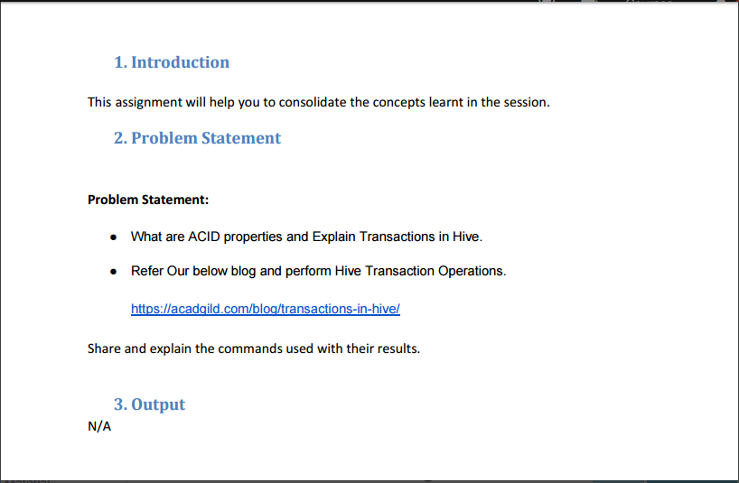

ACID Properties:

ACID stands for Atomicity, Consistency, Isolation, and Durability.

**Atomicity:**

Atomicity means, a transaction should complete successfully or else it should fail completely i.e. it should not be left partially.

**Consistency:**

Consistency ensures that any transaction will bring the database from one valid state to another state.

**Isolation:**

Isolation states that every transaction should be independent of each other i.e. one transaction should not affect another.

**Durability:**

Durability states that if a transaction is completed, it should be preserved in the database even if the machine state is lost or a system failure might occur.

These ACID properties are essential for a transaction and every transaction should ensure that these properties are met.

Transactions in Hive:

Setting the Configurations:

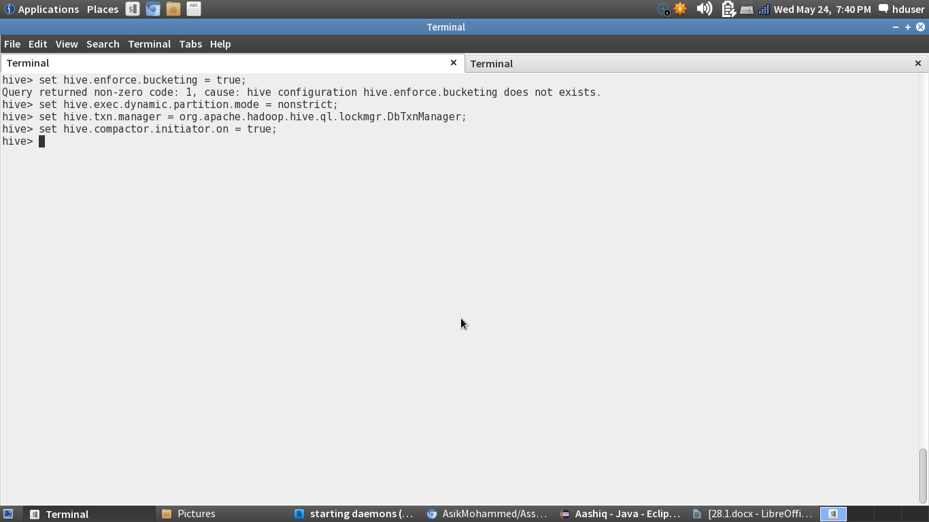

Creating a table and inserting data:

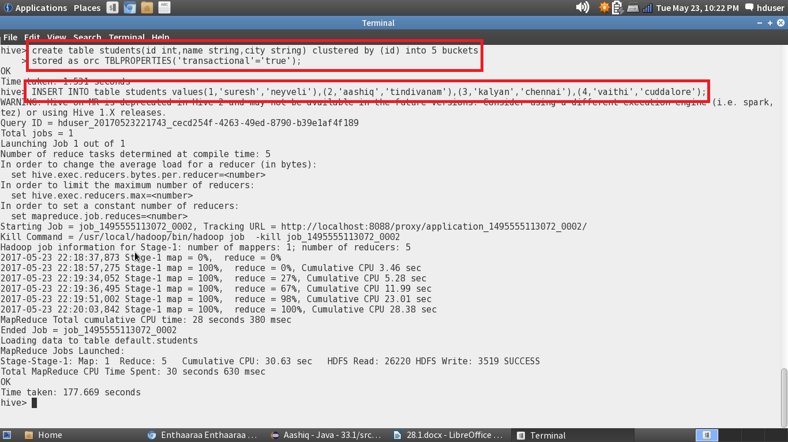

Displaying the data in the table:

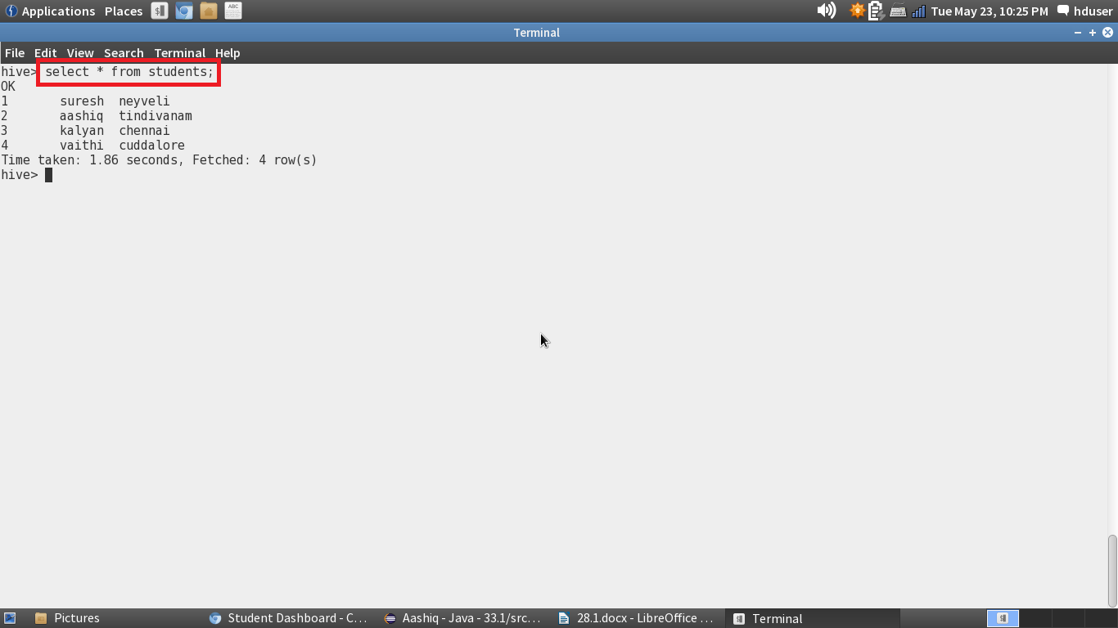

Append operation:

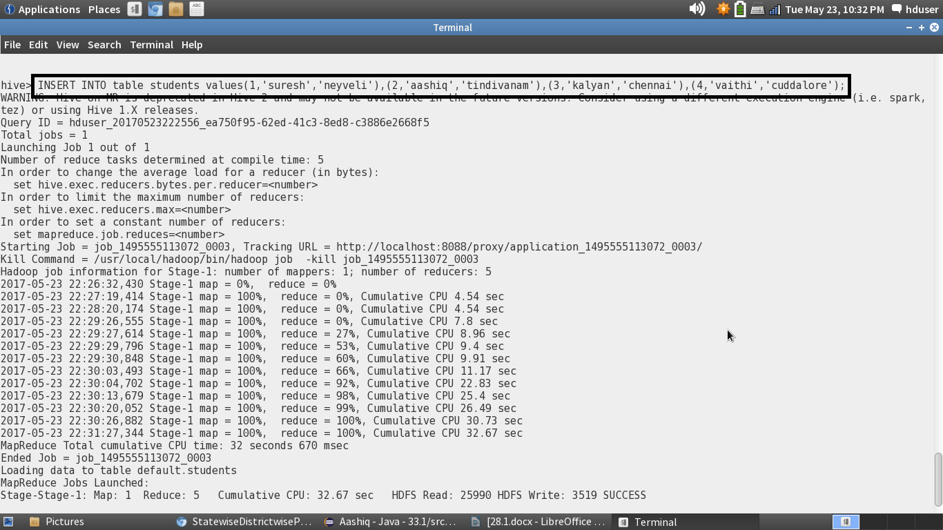

Displaying the table after the append operation:

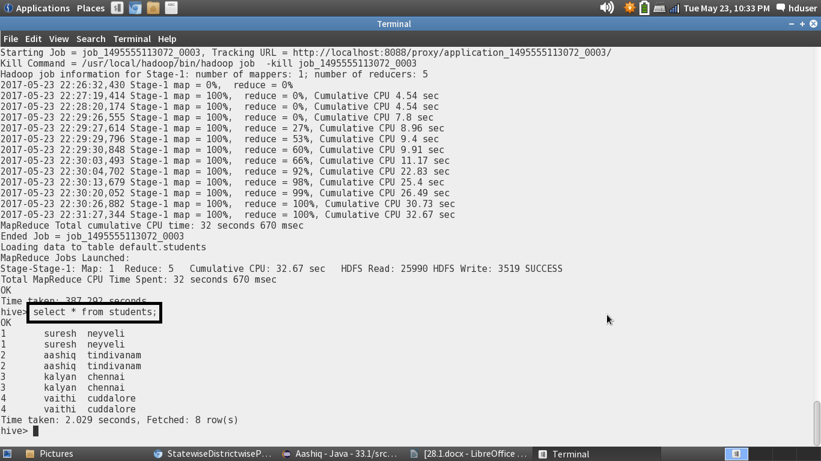

Update Operation:

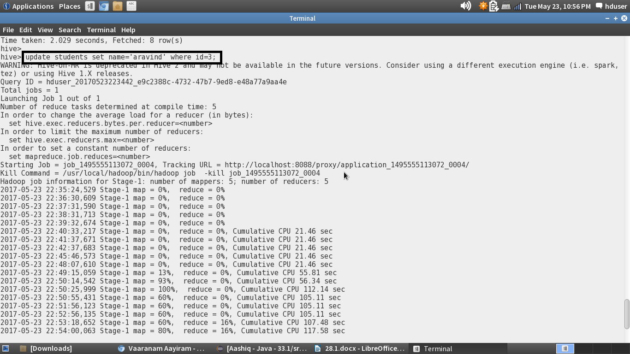

Displaying the table after the update operation:

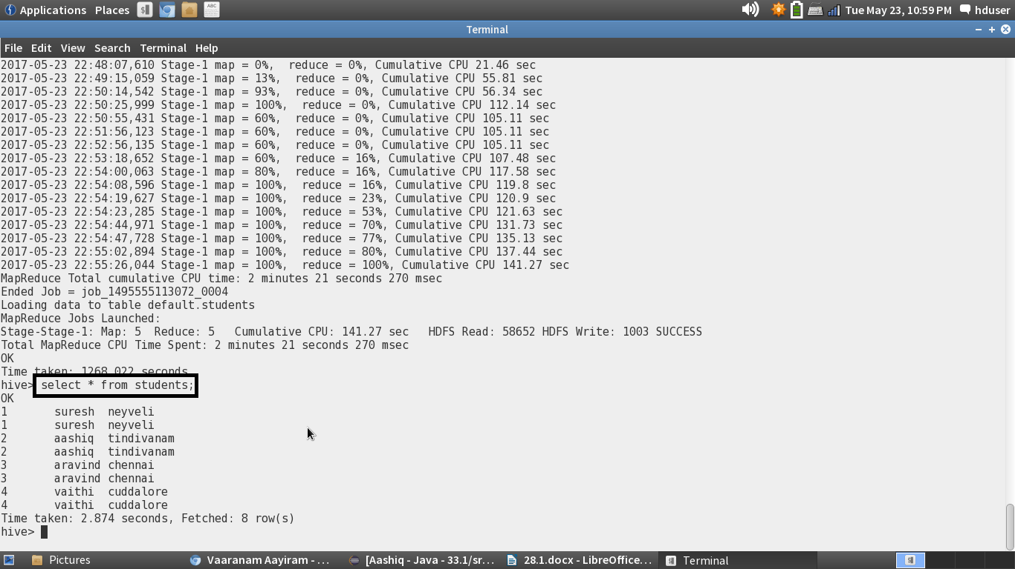

As we can see that the name kalyan is changed to aravind after updating.

Delete operation:

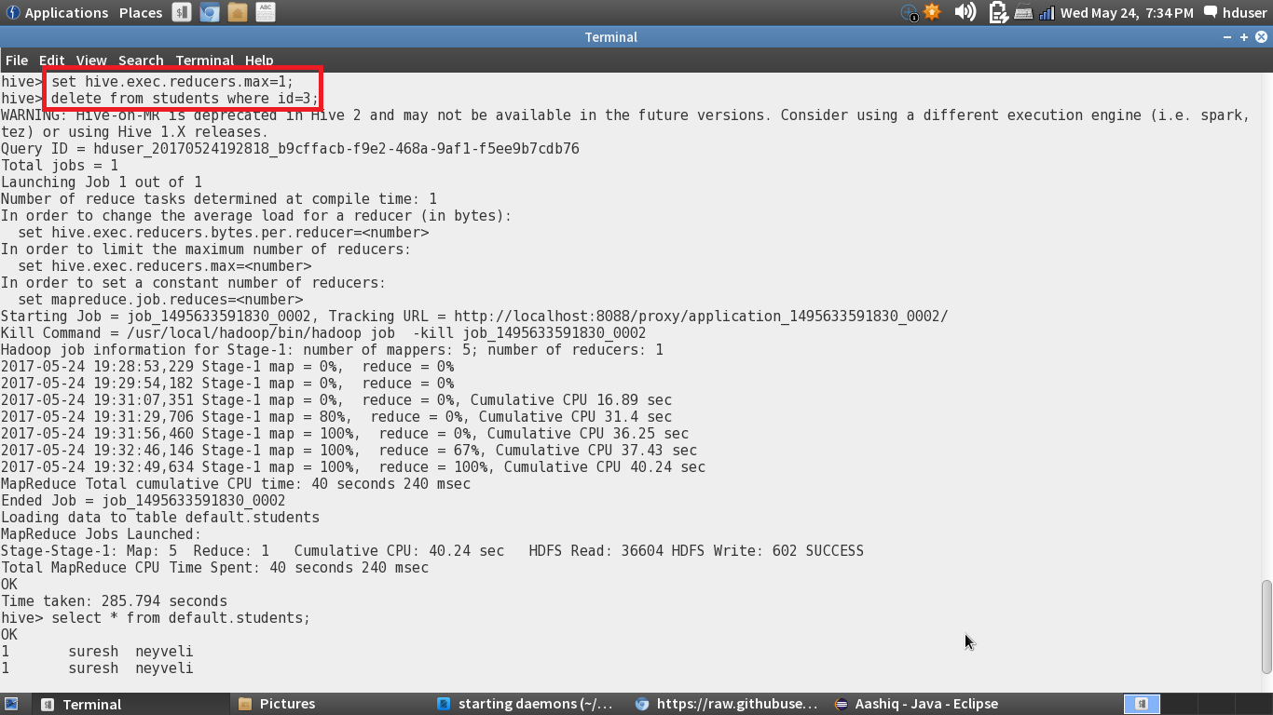

Displaying the table after the delete operation:

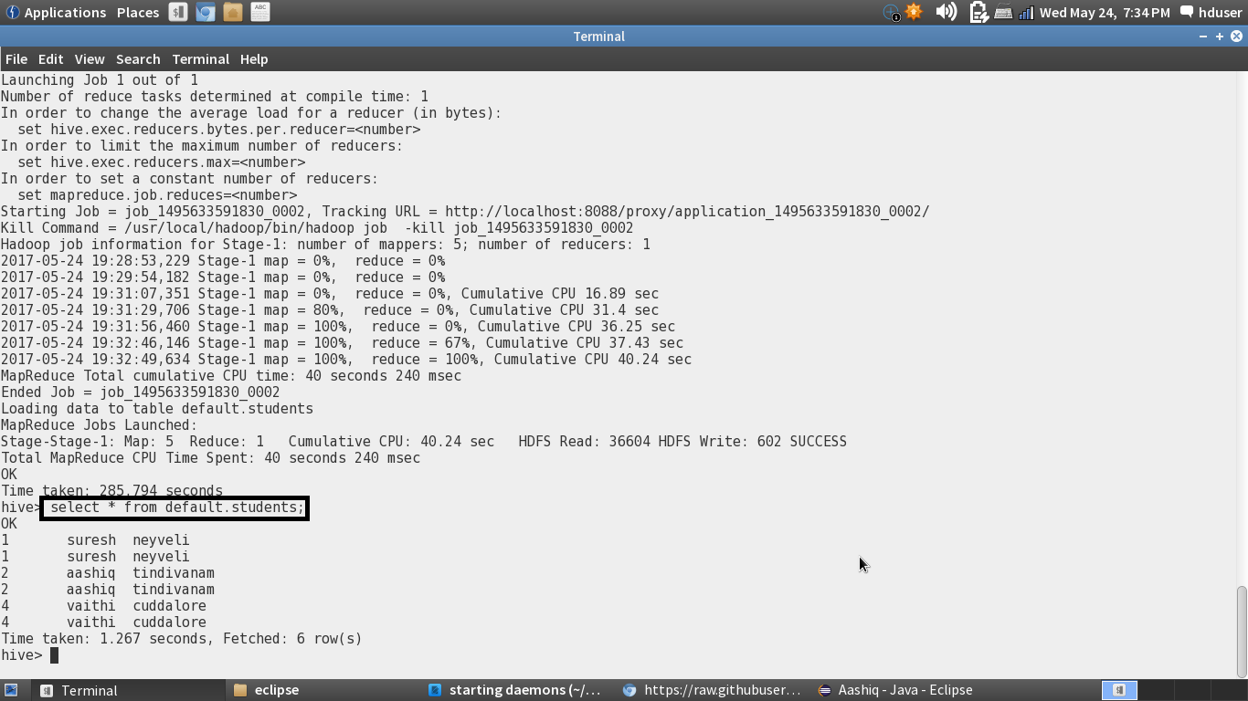

The third row is deleted after the delete operation.